**Electromechanical 3D**

**Printed Prosthetic Arm Initiative**

ME 575: Final Design Review

May 8th, 2023

Kansas State University

Department of Mechanical and Nuclear Engineering

Sponsored by Dr. Ronald Brockhoff

KSU-1 Design Team

Michael Arnold – Sam Boselli – Paige Durand

Talon Hanssen – Julien Illo – Jonathan Perez

Advised by: Dr. Terry Beck

Executive Summary

As engineers are often tasked with refining designs over multiple iterations, this project aims to be the starting point for the extended design process of a low cost, fully 3D printed prosthetic arm. The project will be passed down through groups in Senior Design II within the department of Mechanical Engineering at Kansas State University, and ideally will result in a completed, consumer friendly product for all consumers seeking a replacement to a biological arm.

This report outlines the steps taken to construct the prosthetic arm from start to finish, including brainstorming, modeling, and coding. The overall design aims to mimic natural arm movements as accurately as possible, with 4 points of articulation (fingers, wrist, forearm, elbow) allowing the prosthetic to perform most basic tasks. Other goals assigned with the project include the ability to pick up an egg and cue ball without damaging either, a Bluetooth control system for prototype demonstration, force feedback to detect when an object is grabbed, and an overall cost less than about $500.

The prosthetic arm described in this report has multiple key features that allow it to complete the required functions, including but not limited to fingers that can be fully 3D printed in a single part, linear actuators to control said fingers that include measurable force output, a 2-part forearm that can rotate 180 degrees, a split body design with snap joins to connect the halves, and a simple servo-based elbow joint. These design features work together to complete each of the specified requirements, and the arm will serve as a starting point for future design groups.

**Table of Contents**

Executive Summary 2

Background 4

Project Statement, Deliverables, and Specifications 6

Project Statement 6

Deliverables 6

Specification 6

Detailed Documentation 7

Discussion of Company’s Requested Deliverables 7

Discussion of Specifications and Their Justifications 7

Customer Identification 7

QFD Discussion 8

Assumptions 8

Function of Product 8

Form of Product 9

Conceptual Designs Discussion and Ranking 9

Prototype Details 13

Drawings 14

Overview of Analysis 18

Configurations and Connections 25

Factors of Safety 30

DFX Analysis 30

Applicable Standards, Specifications, Codes 31

Cost 33

Validation and Verification: Plan or Results 33

Bill of Materials 33

Gantt Chart 35

Ethical and Safety Considerations 35

Global, Economic, Environmental, and Societal Considerations 36

Recommendations 37

Conclusion 39

Acknowledgements 39

References 40

Appendices 42

A. QFD Discussion Ranking 42

B. Detailed Drawings and Spec Sheets 43

C. Original Data 51

Background

A prosthetic limb is any device that fills in the role of a severed or missing appendage. There are lots of prosthetics to replace arms with solid pieces that can only simply grip objects, but there are also mechanical prosthetics which use a process called ‘microprocessor prostheses’ to control the movement [1]. The most common types are mechanical arm prosthetics which give partial to full mobility back to an amputee. There are many products available, with a wide selection for personalized needs. With the ability to regain near complete arm functionality again, amputees can continue with their lives how they once did, and in many cases return to their same jobs. Unfortunately, the only available custom mechanical arms on the market range in price from $20,000 to over $80,000 [2].

The LUKE Arm by Mobius Bionics is one of the most advanced microprocessor prosthesis devices currently on the market. It is also the only arm on the market with an articulating elbow joint. This arm is fitted with up to 10 articulating joints which includes control for each finger joint separately using what they call an “IMU”. The IMU is placed in the user’s foot sole and detects different angles of ankle movement to move the arm with extremely high precision. The arm features a very human shape and dimensions as well as a soft silicone hand [1]. With all these features it would seem only natural to want to choose this prosthetic. The only problem is the cost, which is upwards of $50,000 [2]. Many of the other arms below this price are much less sophisticated and do not offer as much mobility.

Open Bionics (OB) and Unlimited Tomorrow (UT) have both done their best to create a low-cost mechanical arm. The Hero Arm by OB, and the True-Limb by UT both costs about $8,000, significant decrease from the cheapest arm listed above [2]. These arms are lower cost due to their manufacturing process and each arm’s simplicity. These arms’ major components are 3D-printed using a durable plastic filament to ensure durability. The companies have also fitted the hands with only the necessary servos and actuators needed to lift and support common objects, further lowering costs. Both have simple independent thumb and finger mobility with a manual wrist rotational lock. The fingers are moved by chords acting like biological tendons to pull the fingers in to the palm and extend back into the open position [3,4]. Because of this process of using a tendon like structure to mimic a biological hands movement, many would consider these bio-mechanical arms. Muscle sensors use the impulses detected by the user to input commands, making the prosthetic finger movements completely independent from the other appendages movements [3,4]. With just these functions, the arms have much less mobility than those listed above, but still provide a great benefit.

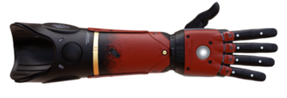

*Figure 1: Hero Arm prosthetic arm created by Open Bionics*

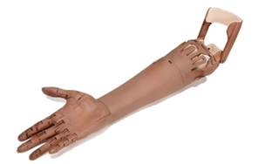

*Figure* 2*: True Limb prosthetic arm by Unlimited Tomorrow.*

While functionally similar, each arm does have their differences cosmetically. The Hero Arm has exterior plates that can be easily removed for customization, shown in red in Figure 1 above [3]. UT has gone for a much different approach making their hand as realistic as possible, as shown in Figure 2. By taking scans of an individual’s remaining arm, they can make a near perfect mirror image of their real arm to get the sizing and shape correct. It is even accurate down to the protruding tendons on the top of the hand [5]. These features add a level of quality that even some of the more expensive options do not.

$8,000 is still an expense that many do not have the money for, so is there a way to make it even cheaper? The physical components of the two 3D-printed arms are unlikely to be even one tenth of the total price it is sold at. But why? A major problem with the medical product field is the extreme mark-up on components when used for aid. This means companies who are making prosthetics must pay an imposed premium on the parts used. These markups can be anywhere from 3 to 5 times the actual cost, and sometimes more [6]. To get around this issue one could buy the parts themselves.

There are over 3 million (about the population of Arkansas) arm amputees worldwide with most of them living in developing countries. There must be a way to create a global solution to give people access to cheaper mechanical prosthesis. 3D-printing has taken the world by storm over the last few years. Over 20 million printers were sold to consumers in 2022 alone [7]. Many companies and consumers now can easily share and print components over the internet. If someone were to make a 3D-printed mechanical prosthetic arm, use only low-cost components available globally, make it easy to assemble, and share all their files online, then feasibly anyone could print and assemble their own arm from their home.

Project Statement, Deliverables, and Specifications

The following content outlines the guidelines required for the prosthetic and the specific items to be submitted for it.

Project Statement

The goal of this product is to design and create a fully 3D-printed prosthetic arm for consumers to use in their daily lives that is more affordable.

Deliverables

The expected deliverables at the end of the project are given as follows:

* Fully 3D printed and functional prosthetic arm.
* Original SolidWorks models for further adjustment by later teams.
* Circuit diagram outlining all connections and components.
* Arduino code to fully control the arm.
* All documentation that was made in the creation of the arm.

Specification

The expected Prosthetic arm must meet the following specifications:

* The prosthetic arm provided must be fully 3D printed out of consumer-grade materials, with a minimal amount of purchased parts (excluding electrical components).
* The hand must be able to detect force feedback and adjust the pressure as required.
* The arm and hand must be able to grab and lift the following objects:
  + A standard cue ball.
  + A standard chicken egg (without breaking).
* The arm must include 4 points of articulation in the following locations:
  + Elbow
  + Forearm
  + Wrist
  + Fingers
* The cost of the fully assembled prosthetic arm should not exceed $500.

Detailed Documentation

The following sections outline the specific design details and considerations used in the prosthetic arm production. Additionally, the reasoning and consumer analysis behind said design choices are included to justify the selected options.

Discussion of Company’s Requested Deliverables

The deliverables requested by Dr. Brockhoff are a 3D-printed arm, SolidWorks models, circuit diagrams, Arduino code files, and any other documentation for the creation of the prosthetic arm. The fully 3D-printed arm is going to be used for the demonstration that the arm created functions as it should and meets the requirements of lifting both an egg and a cue ball. The SolidWorks models will give future design or research groups reference material to improve or build off the previous rendition of the prosthetic arm. Circuit diagrams and the Arduino code are needed to see how the mechanical components of the arm work and how the circuit needs to be set up to achieve these results. Dr. Brockhoff also wants any reference material used to create the prosthetic arm to be given so that it can also be seen by future designers. All the requested deliverable materials will be sent to Dr. Brockhoff via email as well as a physical drive will be given.

Discussion of Specifications and Their Justifications

The specifications for the prosthetic arm are to ensure that it meets the basic requirements and functions Dr. Brockhoff requested. First, all custom components of the arm must be 3D-printed including the main housing and small parts. This is to ensure easy and cheap access to the parts for anyone around the world. Second, the arm must include full range of motion, meaning all components must move in the same manner that a biological arm would, or close to it. Third, for the user to have the best experience, the arm will notify the user of the grip strength being applied to the objects they are manipulating. By having this feedback, the user will be able to pick up a broad range of objects from very fragile (an egg) to very heavy (a cue ball). Lastly the components must be low cost and readily available. To ensure the products are outreached to all individuals, no parts unobtainable or unsustainable globally shall be used.

Customer Identification

Based on the provided project requirements, details, and assumptions, the target consumer has been identified with the points below:

* Amputees missing their arm above the elbow.
* Amputees requiring a mechanical limb for use in their job or daily life.
* Amputees in financial need or those which desire a lower-cost prosthetic limb.

The goal will be to create the product in a way so that anyone will be able to easily obtain and assemble the components for the product. This will include a large variety of people as this problem affects all demographics. The customer base is large due to the project's non-profit-based structure. Without the need to make money, the amount of outreach the product can have will be much wider.

QFD Discussion

Once the target consumer and assumptions had been defined, a list of primary and secondary needs was created to compile the multiple features required or desired in the prosthetic. The list can be found as Table 1 in Appendix A and is not organized outside of the primary needs. The primary needs act as a guide to the final total functionality and restraints of all the design components. To ensure linear product development with each semester’s change in group expectations, a list has been developed to include all aspects of the design and not just the components specific to the team of spring 2023. This helped define what the arms functionality should be.

Each need was then assessed and was assigned to a KANO model type [8] and 1-5 ranking. The three KANO model types are basic, performance, and exciting. Basic needs are essential to the product and must be included. Performance relates to the functionality of a product and how well it performs. Exciting aspects are the functions that are not essential to the functionality of device but could be nice to have. The list of secondary needs was then sorted and placed into one of these three categories. This breakdown of need helped the group divide the project's needs and rank the importance of each.

The importance level was assessed on a 1-5 scale, with 1 being the least concerning design element and 5 the most important. This ranking determined the specific elements to focus on and which to keep in mind as development of the body and mechanics of the arm continued. These elements are highlighted in orange and will be considered first in the design. In the later design focused sections, the specifics of how each part will accomplish these goals.

Assumptions

The following assumptions were made to narrow the target consumer and restrict the goals to a practicable quantity.

* The user has assistance assembling and equipping the prosthetic.
* The user has access to a 3D printer to fabricate the parts.
* The user is only performing basic tasks with the prosthetic (grabbing and lifting objects within the specified weigh, temperature, and movement limits)

Function of Product

The product will have a modular-based design, allowing simple replacements by the consumer and customization of the parts to fit user specifications. The product will contain four major parts: hand, wrist, forearm, and elbow attachments. All major parts can be 3D printed by the consumer to be cost effective and enable quick replacements.

Each major part will be designed to have a realistic human range of motion as to appeal aesthetically to a wider range of people. The hand will be fully modular with individual moving fingers and thumb that all contract to lift items no matter the geometry of the object. The wrist will have a vertical range of motion of about 30 degrees, with the 90-degree mark will be in line with forearm. The forearm will have 270-degrees of freedom but will only utilize 180-degrees, 90-degrees in the clockwise rotation and 90-degrees in the counterclockwise rotation, which will be the same range of motion as a non-prosthetic forearm. The elbow will have a range of motion of 90-degrees and will be able to lift the forearm and hand while there is a weight attached to the hand.

Form of Product

The product is designed to imitate the human form with small sacrifices to allow each part to contain the components required for its function. The small sacrifices include decreased range of motion, tactility, size, and mobility, mostly affecting the hand. Each part will be able to be 3D printed using a polylactic acid (PLA) filament alongside any 3D printer that has the following dimensions: 210 × 210 × 250 mm (8.3 × 8.3 × 9.84 in). The hand and fingers are printed as a single part with the joints having pins with a small tolerance to allow mobility in the vertical direction once the product finishes printing. The product will be constructed and assembled by the consumer as the product is meant to be open source, therefore what will be provided to the consumer are the files to print and edit the product, the Arduino code, and the component list for purchase as well as the components specifications.

Conceptual Designs Discussion and Ranking

For simplicity, this project has been broken down into 7 main components as follows:

1. Fingers
2. Thumb
3. Muscles
4. Wrist
5. Forearm
6. Elbow
7. Force Feedback

Each individual component has multiple design options with varying pros and cons. In the following sections, some of the main design options will be evaluated based on their ease of assembly, cost, and general functionality.

It should be noted that these designs and explanations were created before any prototype work was completed, and thus does not necessarily reflect the final designs.

1. Fingers

For the fingers, two main design options were selected: snap fit and print-in-place (PiP). The snap fit option included two secondary options by utilizing either a ball and socket or cantilever joint. The snap joints were chosen over standard pin joints to reduce the number of parts required to assemble the hand. With the snaps built into the fingers, the user could easily assemble the hand digits without trouble. Early in the design process, though, the snap joints were found to be inferior to the PiP joints as they were too difficult to create using a 3D printer and still required some assembly, while the PiP joints are printed fully assembled. An early model of the PiP finger is seen in Figure 3 below. Overall, the PiP joints excel in instant assembly, equal price to the other options, and function just as if not better than the snap joints.

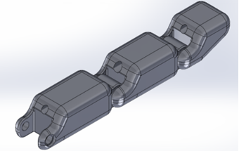

Figure 3: Early PiP finger design

2. Thumb

The thumb is designed without bending joints and instead rotates within the palm along the hand's length axis, as seen in Figure 4. This design reduces the number of moving parts in the hand, and consequently improves the ease of assembly. This design is also cheaper than a jointed thumb as it can be controlled with a low power servo motor. Finally, rotating thumb can help the user pick up small objects with a controlled pinching motion, and large objects by acting as a stable contact point.

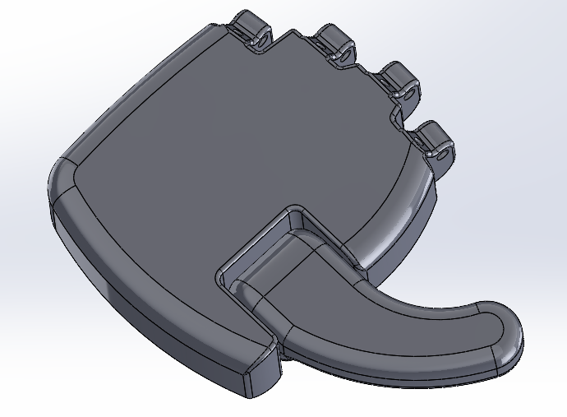

Figure 4: Early model of the palm design.

3. Muscles

The three muscle design options were a dual-spool DC motor setup, the standard servo and elastic, and linear actuators with steel wire. The dual-spool DC motor setup was too large and complex to easily fit within the body of the hand, as the string would need to be diverted along the fingers from the spool. The servos created a similar issue, since the size of the servos required to create significant force would need to be placed within the forearm, not the hand. The linear actuators are both small and powerful enough to create an adequate grip force. Additionally, the steel wire completes both the tension and extension process without requiring the user to tie any strings to the fingers. While the linear actuators are more expensive than the other two options, this is considered an acceptable tradeoff.

4. Wrist

The wrist had two designs, one with a servo motor and another with a linear actuator. For the servo, it was determined that the motor would not be strong enough to properly lift objects without adding any additional gearing or purchasing a larger, more expensive motor. These gears would both take up a significant amount of space and increase the difficulty of assembly. The linear actuator attaches directly to the forearm and hand, providing a simpler, stronger joint at a cheaper cost. The only tradeoff is the actuator is exposed while fully extended, though this was considered acceptable.

5. Forearm

The forearm only had a single design option for both the assembly and rotation. The upper and lower forearms are made of two separate halves, as seen in Figure 5, which snap together to lock in all the components inside, including the servo that controls the rotation.

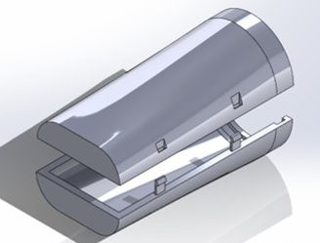

Figure 5: Early model of the forearm design.

6. Elbow

The elbow is considered the least vital component of the arm as its only purpose at the time of this report is to act as the main form of locomotion for testing. Due to this, the elbow consists of only a single high-strength servo motor with a simple gear ratio to further increase the torque. The servo will attach directly to the base and forearm to achieve approximately 90 degrees of movement.

7. Force Feedback

For force feedback there will be a thin film pressure sensor on the fingertips that act as resistors, changing their resistance with pressure. This sensor can be seen in Figure 6. By placing the pads at key points along the fingers, the pressure, and therefore the force, can be determined and used to find the minimum and maximum amount of pressure needed to not crack the egg but still be able to lift it without dropping it. This is not yet a final design option, as more testing is required. The pads are adequate as a low-cost initial testing resource.

Figure 6: Thin Film Pressure Sensor

Prototype Details

The initial prototype featured only a small number of the selected features explained in the conceptual designs and rankings section. An early hand prototype was completed and included early variations of the print-in-place fingers and an empty palm for further testing and can be seen in Figure 7. The newest hand prototype seen in Figure 8, and still uses the PiP method and has a more refined thumb to give a more natural appearance. There have been reconfigurations on the fingers, hand, and wrist and new developments on the lower forearm and elbow joint.

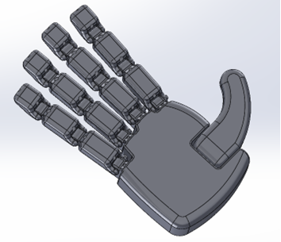

Figure 7: Early model of the complete hand.

Figure 8: Final Model of the complete hand.

Drawings

While selecting the design choices explained above, multiple sketches and conceptual models were created to improve the clarity of each idea. Some of the sketches and models are included below to further add detail to the thought process involved in the final choices.

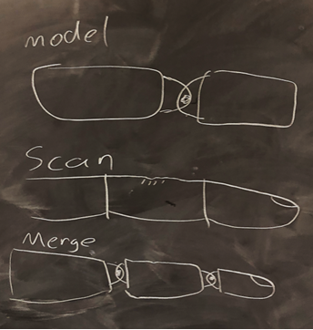

Figure 9: Early sketch of potential finger design.

The sketch in Figure 9 depicts an early concept which utilized a high-quality 3D scanner to create ultra-realistic finger models, then merge those models with the chosen joint type. This idea was ultimately discarded since not all users would have the same fingers, and thus the prosthetic would not be as universally designed.

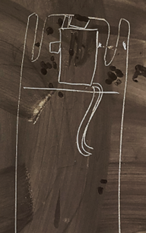

Figure 10: Early wrist concept drawing

The sketch in Figure 10 depicts a wrist design using a direct connection to a servo motor. This servo would directly attach to the hand to allow rotation. The design, though simple and cost effective, was discarded because it would not allow for the range of motion needed and theoretically would not withstand the weight of picking up an object. To increase the lifting capabilities of the motor, multiple gears would need to be included in the design, which complicated the assembly process beyond acceptable levels.

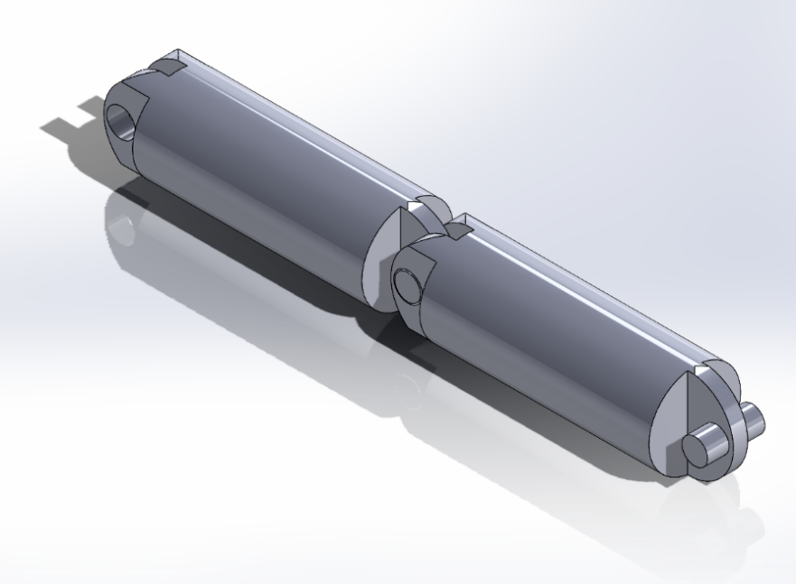

Figure 11: Early Print in Place finger

The first PiP (print in place) finger design is provided in Figure 11 and acted as the proof of concept for the PiP finger design working for less assembly. Although functional, the initial design was unnatural and inefficient, including excess degrees of rotation. A newer, cleaner iteration of the model is seen in Figure 3.

Figure 12: Initial palm design

The model of the initial palm design is seen in Figure 12 and acted as a general size reference for later designs. Additionally, the initial palm design included space for a jointed thumb, which was later discarded for increased efficiency and simplicity. A later iteration of the palm can be seen in Figure 7, which includes the PiP fingers attached.

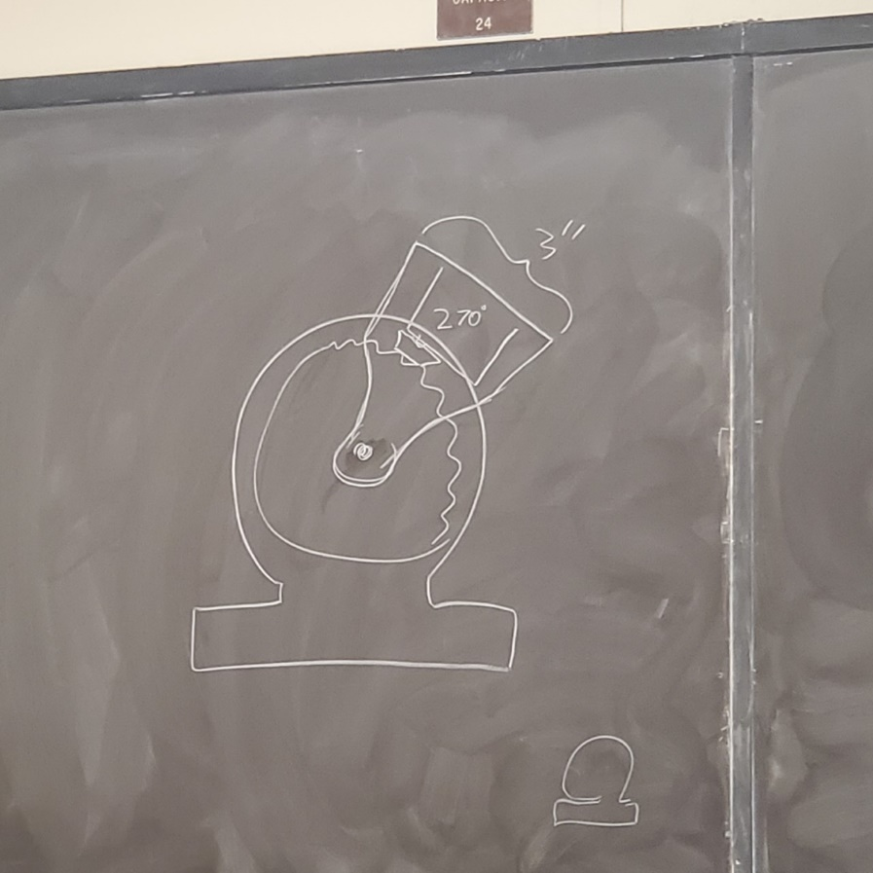

Figure 13: Initial elbow sketch

The sketch in Figure 13 depicts the first idea for an elbow joint for the prosthetic arm. The base plate at the bottom of the elbow would be placed and secured on a table for demonstration. The lower forearm portion would connect to the elbow joint using a pin through the center. A gear would be placed in the center of the forearm and elbow joint connection which would move the whole arm up and down. A servo with a gear attachment would be placed in the lower portion of the forearm to move the elbow joint gear. This idea was later changed due to concern that too much force was being put on the gearing system that could lead the joint to break or fail to lift objects.

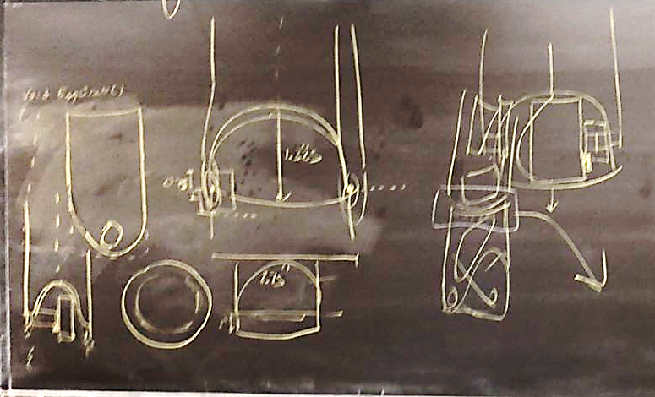

Figure 14: Miscellaneous elbow sketches

The sketch shown in Figure 14 is the second idea for the elbow joint that would connect to the lower half of the forearm. This design was created to have less of a gap between the elbow and forearm and to give a more natural appearance. The up and down rotation of the elbow will still be done using a gear and a servo motor.

Overview of Analysis

The desired outcome of the prototype is to maintain as much of the traditional forearm’s capabilities as possible while also meeting the specifications of the deliverables stated in this report. Further development of the prototype by future project group is likely since the current iteration is still in need of refinement.

To match the earlier formats, the overview of analysis has been split into nine sections as follows:

1. Code
2. Electrical Components
3. Fingers
4. Thumb
5. Muscles
6. Wrist
7. Forearm
8. Elbow
9. Force Feedback

1. Code

The code for the demonstration is a basic remote-control program utilizing the built in Bluetooth capabilities of the ESP32 microcontroller and the Dabble app. A schematic of the gamepad control scheme is provided below:

Figure 15: Control guide for prosthetic Hand Control mode.

Figure 16: Control guide for prosthetic Arm Control mode.

Notice that the code utilizes two main states for either arm or hand control. This functionality was implemented to make full usage of all the buttons provided on the Dabble gamepad. The only unique autonomous functions that don’t manually control a part of the arm are the cue ball and egg grab functions, seen in Figure 16 on the Square and Circle buttons. These buttons initiate the automatic grabbing process in which the fingers extend to an open position, then slowly close until the pressure read by the in-hand sensor reads a specific threshold value (pressure sensors explain in section 9). A simple flow chart of this process is provided in Figure 17:

Figure 17: Movement flow chart of automatic grabbing functions

2. Electrical Components

The entire prosthetic utilizes only eight major electrical components, and are listed below:

1. 6V Linear Actuator x2
2. Thin Film Pressure Sensor
3. MG90 Servo
4. 12V Linear Actuator
5. 25kg Servo x2
6. ESP32 Control Board

Each of the components listed can reliably be powered by 12V or 6V, depending on the component. Thus, to power the full arm for the final demonstration, a 12V AC-DC power supply is used alongside two variable DC-DC buck converters. A detailed explanation of the power system and wiring diagram is provided later in the document, and the spec sheets for each part can be found at the second half of Appendix B.

While the voltage rating of each component is broad enough for some variation, the current ratings are significantly stricter and can cause the arm to fail if not properly adhered to. The total current draw of all components at maximum power (excluding the 12V actuator) was roughly calculated to be 6.5 amps. Assuming not all parts would be drawing maximum power simultaneously, this number was reduced to 6 amps. This value allowed the usage of just two DC-DC buck converters to power all the 6V components without breaking the system. A detailed wiring diagram is provided later in the report.

3. Fingers

The print-in-place fingers (PiP) provide easy assembly and fast printing while not losing any of the dexterity or range of motion that simple pin joints provide. The PiP fingers enable a modular design with the ability to print new fingers as needed. Since the PiP fingers have virtually no assembly time, they will provide a consumer-friendly experience and a low barrier of entry. The fingers, shown in Figure 17, have one joint at the base and one at the knuckle. The tips have been designed with a slight bend to increase the grabbing ability of the fingers while eliminating the need for an additional joint. While not shown, the fingers are also wrapped in common sport-grade grip tape to increase traction when picking up smooth objects.

Figure 17: 3D model of final fingers attached to the palm

4. Thumb

The solid thumb with only a single rotational joint at its base allows for increased printing and assembly speed, while also further increasing the simplicity of the hand. The thumb can rotate approximately 110 degrees from its starting position parallel to the hand, this motion is seen in Figure 18, which allows it to meet the pointer and middle fingers. By meeting at a single point, the fingers and thumb work together to create a simple yet effective pinching motion used in grabbing small objects. Like the fingers, the thumb is wrapped in grip tape to increase its gripping ability.

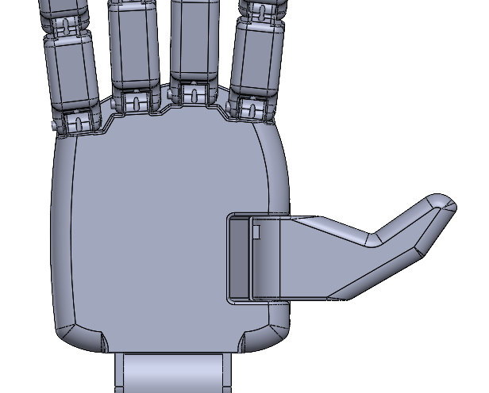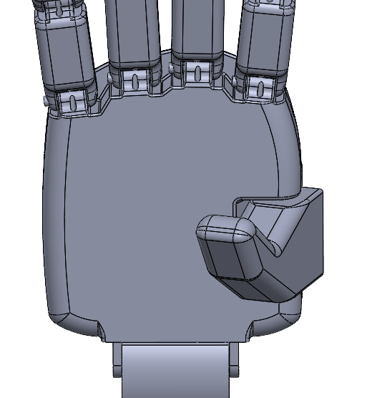

Figure 18: Model of the thumb design in extended and contracted positions.

5. Muscles

The only “muscles” included in the arm take the form of plastic hanging wire which connects the hand actuators to the fingers. By pulling on the wire, the fingers move inward, creating a natural gripping motion. To withstand high repetitions of high tensions due to the powerful actuators, the wire selected is 20lb hanging wire. In addition to high strength, the wire is both stiff enough to extend the fingers to a natural position when not taut, but still flexible enough to tie into a knot and attach to the fingers.

While the 20lb hanging wire is effective, other options should still be considered and tested to ensure the best possible option is implemented into the design. Ideally, the replacement wire would perfectly balance rigidity, flexibility, and strength.

6. Wrist

The wrist, shown in Figure 19, acts as a simple hinge joint for the hand to attach to. Its movement is controlled by a high-strength linear actuator that grants about 30 degrees of movement. Additionally, the wrist has a passage for the hand wires to travel through, preventing them from bending or pinching.

While effective for the prototype, the current actuator used in driving the wrist is the only device within the arm that runs on 12V. In the future, it is recommended that this part is swapped for a 6V option of higher or similar strength. Although more expensive, it should reduce the number of parts required in stepping down the voltage and help simplify the electrical circuit.

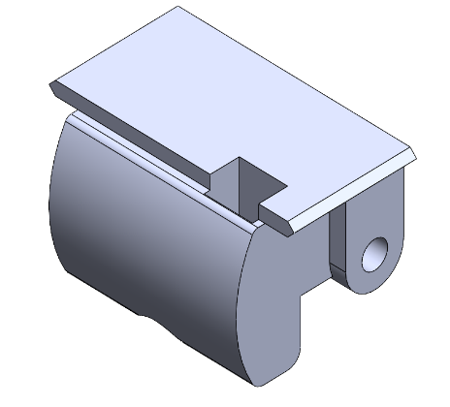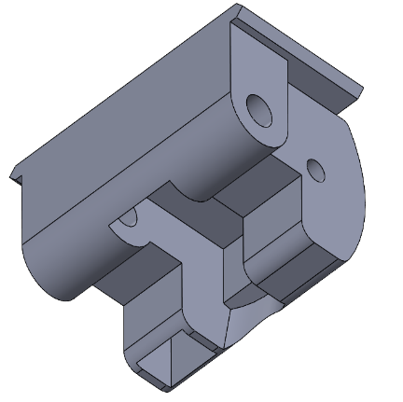

Figure 19: Model of the final wrist design.

Figure 19: Wrist

7. Forearm

In order to simulate a realistic arm rotation, the forearm is split in two parts that move independently of each other. The forearm is comprised of two separate sections using snap-fits to connect the two halves. The top half section, the left object in Figure 20, is rotated using a servo and gear system, and features the mounts for both the wrist joint and linear actuator. The bottom half, the right object in Figure 20, is considered the stationary portion and houses the servo that rotates the upper half. Additionally, all the electrical and control components are housed inside the upper half of the forearm, including the buck converters, ESP32 control board, and general wiring.

The main change that could be made to the forearm involves the snap fits and servo selection. The current snaps are not optimized and need further development to function as intended. Additionally, they could be removed altogether and replaced with a different connection system. The servo, on the other hand, is too large and has an excessive maximum torque for its current location and purpose. In the future, it could be swapped with a smaller model that has a smaller torque rating to create more space for the wires running to the breadboard.

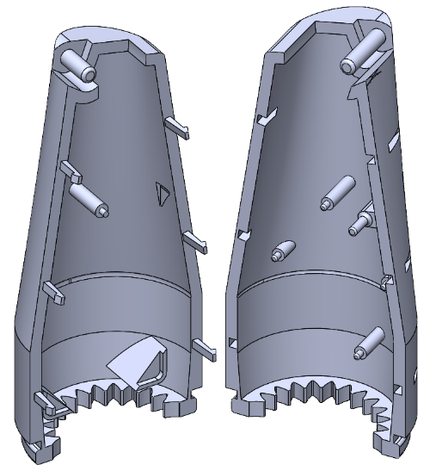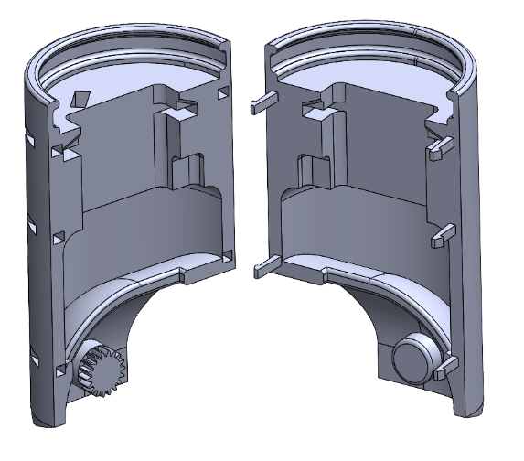

Figure 20: Model of the final upper and lower forearm design.

Figure 20: Model of the final upper and lower forearm designs.

8. Elbow

The elbow, shown below in Figure 21, is by far the simplest part of the arm. The joint acts as a simple pivot point for the arm and housing for the elbow servo. While mechanically simple, the elbow has been specifically designed to create a natural transition between the arm mount (not included in the report) and forearm. To move the forearm, a 25kg servo is fitted with a small gear and inserted into the elbow joint. This gear meets with its counterpart on the lower forearm, then the servo can be rotated to move the arm. It should be noted that after extensive testing, it was determined that the 3D-printed gear could not properly interface with the servo, and the elbow joint is currently not functional. To reduce stress on the electrical system, the elbow servo has been removed from the assembly for the current prototype.

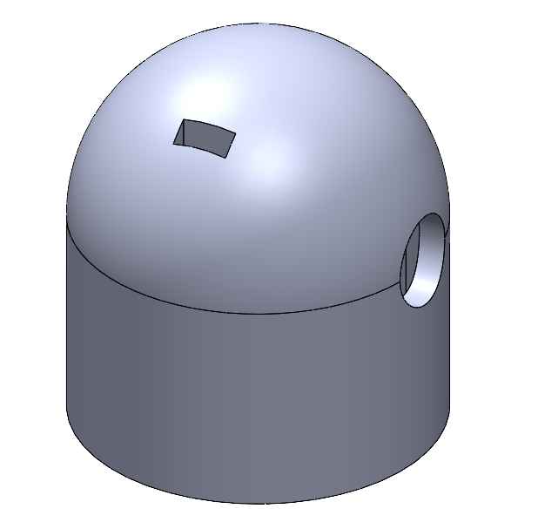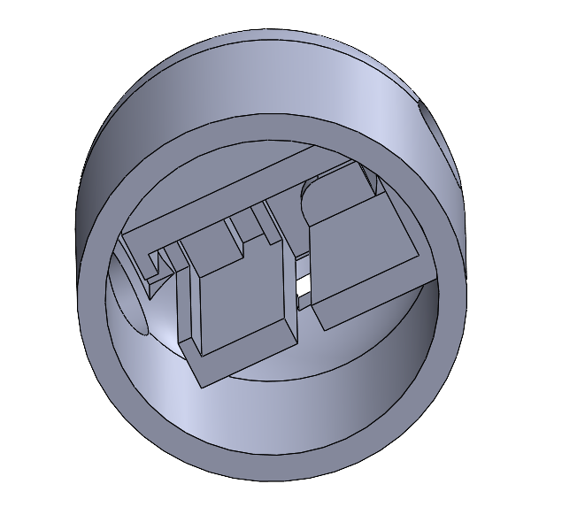

Figure 21: Model of the final elbow design.

Figure 21: Elbow base

9. Force Feedback

The force feedback function is primarily completed by a single RP-C resistance type pressure sensor inserted between the front of the linear actuator that controls the pointer finger and the inner wall of the hand, and can be seen in Figure 6. The sensor acts as a variable resistor whose resistance decreases with applied pressure. The sensor is securely attached to the actuator via a small amount of liquid adhesive, and when the fingers are extended hangs loosely against the inner wall of the hand. Once the fingers are drawn in (to grab an object) the linear actuators push against the wall of the hand, conversely pinching the pressure sensor. This pinching action changes the resistance of the sensor, which then affects the voltage sent to the ESP32, resulting in a simple force feedback mechanism. It should be noted that the sensitivity of the sensor has been tuned by branching a 1.9kΩ resistor to ground from the signal pin. The magnitude of this branching resistor can drastically affect the sensitivity of the sensor, and thus should not be changed by large values.

Configurations and Connections

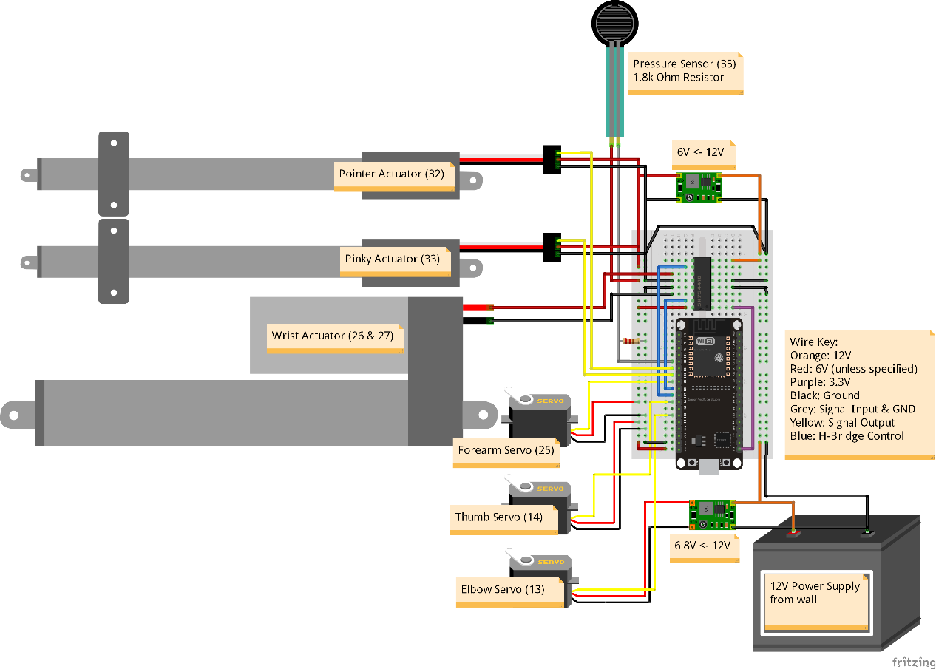

Figure 22: Diagram of the final wiring schematic with labels.

The complete circuit diagram is provided above in Figure 22 and includes all the working components used in the final demonstration. It should be noted that the wrist servo, which is connected to pins 26 and 27 in the wiring diagram, is controlled using a basic H-Bridge as it is not “servo based.” In addition to wiring, the diagram also includes labels indicating which pin on the ESP32 each part should be connected to. Finally, a key describing the purpose of each wire color is included to increase the ease of assembly.

Although functional, the electronic system within the arm should not be considered optimal and requires further refinement to work at peak efficiency. Some potential changes to be considered include upgrading the buck converters for models that offer higher current output, swapping the 12V actuator for a 6V model of similar capability, and the implementation of a mobile battery pack. To meet deadlines and ensure the functionality of other sections of the arm, this optimization has been left to later iterations of the project.

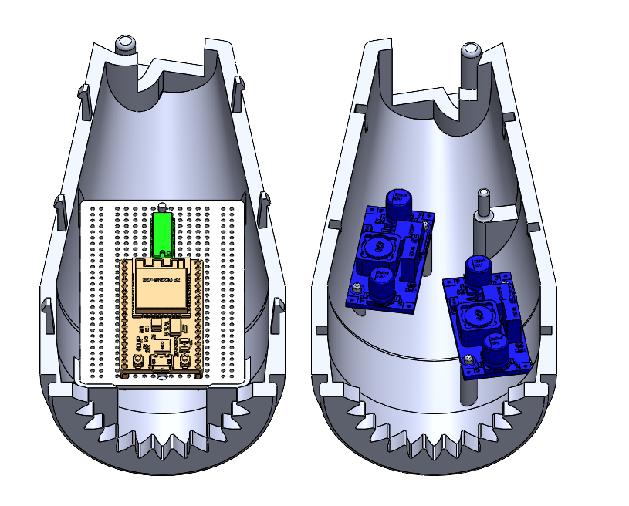

Figure 23: Assembly of the supporting electronics mounted into the upper forearm.

Figure 23 displays the main breadboard and buck converters placed on their respective mounts within the upper forearm. On the breadboard, both the ESP32 control module and the h-bridge module are attached, with the wires for each other component attached to said breadboard.

Figure 24: Hand assembly with actuators and sensors

The exploded view of the hand is shown in Figure 24. The shafts of the linear actuators (not pictured) are equipped with sliders that allow said actuators to move the strings. The actuators can then slide snuggly into the hand and are held down using a spacer. The wrist joint also slides into the bottom part of the hand, and the entire system is held down with a screwed lid.

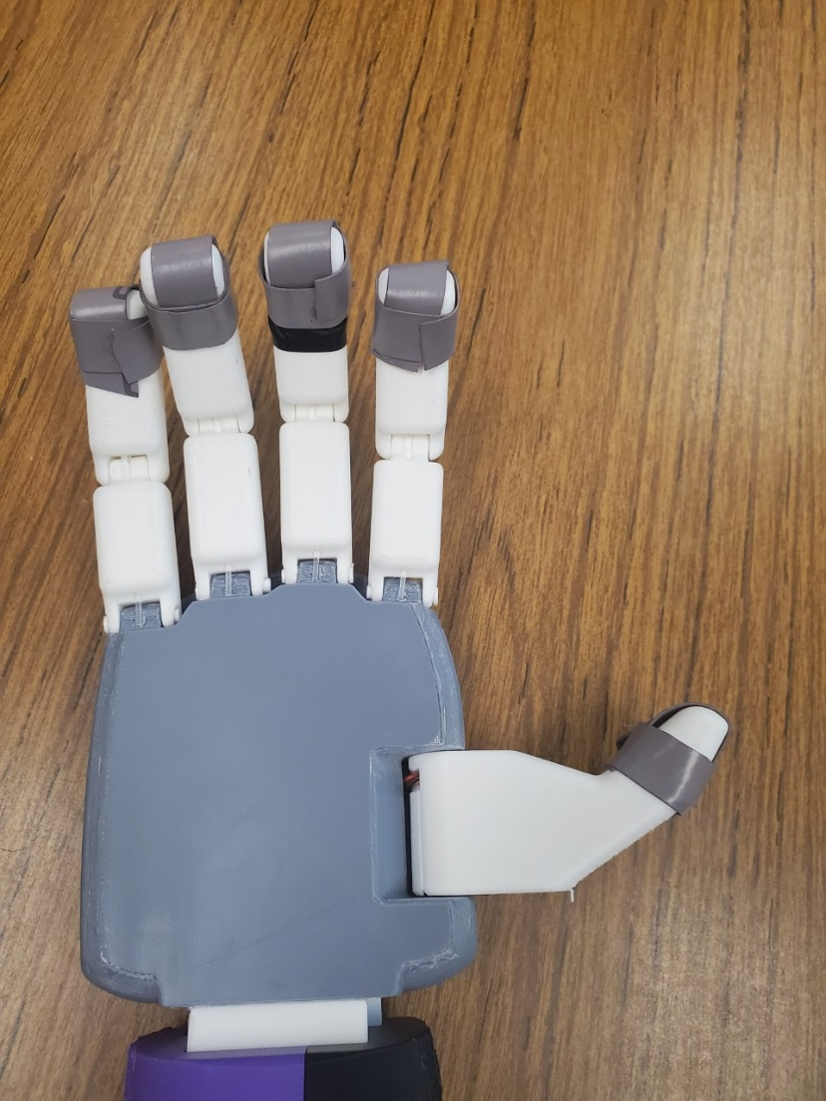



Figure 25: Finger assembly with wires highlighted in red.

A picture of the finger assembled fingers is shown in Figure 25 and displays the wire that controls the finger motions highlighted in red. Said wire is connected to the linear actuators via the previously mentioned slides and contracts the fingers as the actuators extend. Additionally, the figure displays the sport-grade grip tape wrapped around the ends of the fingers. This grip tape, although aesthetically crude, greatly improves the gripping ability of the hand.

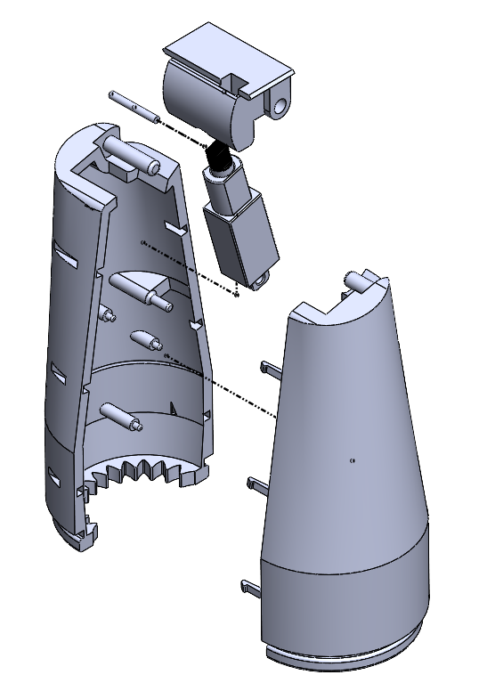

Figure 26: Upper forearm and wrist assembly

The upper forearm assembly (not including the main breadboard and buck converters) is pictured in Figure 26 and displays how the wrist actuator attaches the wrist to the main part of the arm. The female lip of the lower forearm is then placed over the male counterpart at the bottom of the upper forearm. This configuration is provided in figure 27.

Figure 27: Lower forearm assembly

The lower forearm assembly is provided in figure 27 above and displays how the forearm servo is held in place by the outside halves of the main body. Additionally, the lower forearm has two pins at the bottom of the female section of the ball joint that connects to the elbow base. One of said pins has a spur gear that interfaces with a smaller gear attached to the elbow servo, which is described in the next paragraph.

Figure 28: Elbow assembly

The elbow assembly is pictured in Figure 28 and displays how the elbow servo is equipped with a small gear and inserted into the elbow base. As previously mentioned, this gear interfaces with the lower forearm to complete the elbow joint and provides basic locomotion for the full arm.

Figure 29: Forearm and elbow assembly

Figure 29 displays the overall assembly of the major arm body (not including breadboard and buck converters). As discussed in previous sections, many of the electrical components and parts of the body are held in place using the corresponding halves. This design keeps all the components in place without using additional hardware, which further increases the ease of assembly and reduces the cost of the arm.

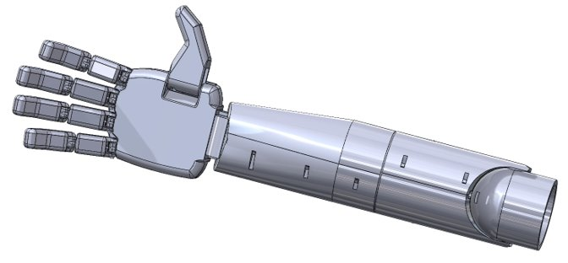

Figure 30: Full arm assembly

The fully assembled version of the prosthetic arm should resemble the image shown in Figure 30. A more in-depth illustration of the assembly process for the arm is given in Appendix B. All the electrical components are completely hidden and encapsulated inside the arm.

Factors of Safety

In the future progression of this prosthetic arm there will be a need for safety testing to ensure that the arm will not cause harm to the user or break when performing tasks. Low voltage electronics can still electrocute a person so there will need to be extensive waterproof testing to ensure that if it is raining or the prosthetic arm gets wet in any way that the user is safe from electrocution and the electronic components are not damaged. The arm will need to be tested for a maximum weight carrying capacity so that the user is aware of how much weight the arm can lift before damage may occur. The last main safety concern would be how the arm fits to the user's pre-existing limb. The prosthetic arm must fit comfortably on the user and not cause any strain on joints or skin irritation when being used. Future factors of safety analysis can be done using CAD programs for theoretical testing and then be tested in person to collect experimental data.

DFX Analysis

Based on the requirements for this prosthetic, there are three major design specifications.

1. Design for cost
2. Design for manufacturability
3. Design for assembly

Designing for cost was mostly focused on keeping the total cost of the prosthetic under $500. Profit was not a concerning factor when evaluating cost since all the 3D printed parts, mechanical components, and electrical components will be at the expense of the user. The process of designing for cost was to figure out what components were needed based on the prototype and then research parts that met the specifications for size, torque, etc. and compare the part’s prices on different reliable websites. Most of the $500 was allocated towards electrical components such as the linear actuators, servo motors, and PCB board. The price of electrical components appears to fluctuate depending on supply and the state of the economy so there was some leeway with the total cost.

Designing for manufacturability mostly consisted of ensuring that all the parts for this prosthetic could be easily sourced for purchasing or could be made using a 3D printer. There is not an assumption that all users would own a 3D printer, so websites were found that allow you to send in the part files and then the company will make the parts and send them to the user. The electrical components that would need to be purchased by the user can be sourced from many different websites. The websites for the parts used for this prototype will be given so that even if the parts are out of stock the specifications for the product will still be known to find something similar.

Designing for assembly was especially important because of the limitations this demographic could face when assembling something as complex as a prosthetic arm if they do not have assistance. The print-in-place printing method for the fingers greatly decreases the number of small pieces the user would have to assemble. One of the smallest assembly components of the prosthetic is attaching the fingers to the palm which will require putting small rods into the joining holes. Another slightly tedious assembly task is to slide the hanging wire through the fingertips. The rest of the prosthetic is made of large parts that snap together and or glue together.

Applicable Standards, Specifications, Codes

Since the goal of the project is not to sell this product for a profit, but rather provide it as a resource, there are very few standards the design must comply with. Looking through the World Health Organization’s (WHO) standards for prosthetic limbs, it is clear there are many hoops the industry must jump through to receive medical approval. There are specifications on manufacturing, safety, and many other regulatory processes for companies and governments to follow. There are many rules in material compliance and sourcing that will simply not be an issue as the parts used are readily available on the market today [10]. There are several standard practices already considered including,

* **No. 10:** “The direct and indirect economic benefits of prosthetics and orthotics services should be analyzed at individual, family, community, society, health sector and national levels.”
* **No. 18:** “International standards should be used for national classification of prosthetic and orthotic products.”
* **No. 23:** “Clinical and technical research should be conducted in prosthetics and orthotics, and the results should be shared nationally and globally.”
* **No. 24:** “Affordable prosthetic and orthotic products that are cost–effective, of good quality and context-appropriate should be developed and made widely available.”
* **No. 30:** “Continuing professional development should be compulsory in prosthetics and orthotics professional practice.”

Many of the standard numbers are skipped in the above list. This is due to many standards being targeted specifically to the government and medical field services, and not the product itself. There are also many regulations on the services needed to be provided to customers directly from prosthetic providers. These services include training, technical support, warranty, and communication with medical providers. These practices will be considered when designing a user manual and other related documentation.

There are a few standards not listed above that were at first not being considered until discovery within the WHO’s standards documentation,

* **No. 19:** “Components, materials, consumables, tools, machines, and other equipment used exclusively for fabrication of prosthetic and orthotic products that are not available in a country should be exempt from import duty and customs fees.”
* **No. 22:** “Prosthetic and orthotic products should be tested structurally for compliance with ISO or equivalent standards before being sold on the market.”
* **No. 32:** “Prosthetics and orthotics service units should have at least one prosthetist and orthotist to supervise and guide clinical and technical work.”

Though not necessary for this round of the project's current goals, it is important to consider the standards above for the end goal completed by future teams. Standard ‘No. 19’ discusses that all medical prosthetic materials and components must be exempt from import and customs fees. As discussed later in the report, there is a large need for low-cost prosthetics in other countries. With the need to make a few custom components for the overall design later down the road, it may be important to consider making them medically approved to help the costs to people outside of the United States.

Standard ‘No. 22’ refers to the use of International Standards Organization’s practices for the specific components. This includes standards for technical specifications, such as strength and quality of components, and unit testing standards [11]. When determining the best mechanical design, it will be helpful to reference these standard practices as they may provide helpful design insight and an overall better product for the user.

Lastly, standard ‘No. 32’ states that a trained prosthetist supervises and guides clinical and technical work. While this mostly relates to the practices of medical facilities disbursement of prosthetics, it may be helpful to consult a prosthetist in fitting and teaching practices when designing some type of guide or instructions for the end user. Hopefully documenting these rules will help future teams to develop their ideas in accordance with industry standards.

Cost

Having an accurate and thorough cost estimate for a project like this is important for planning the rest of the project. The estimate for the project can be seen below in Table 1. The predicted costs fall within the budget that was allocated for a final product, but it will be important to continue to cut costs to keep this project as accessible as possible. The cost of these parts is based off the price listed on the website where they were bought.

Table 1: Cost Analysis

|  |  |  |  |  |
| --- | --- | --- | --- | --- |
| **Part** | **Quantity** | **Cost (each)** | **Total Cost** | **Website** |
| Hand Linear Actuators | 2 | $70.00 | $140.00 | Actuonix |
| Thumb Servo Motor | 1 | $10.99 | $10.99 | Amazon |
| Wrist Linear Actuator | 1 | $28.99 | $28.99 | Amazon |
| Elbow Servo Motor | 1 | $16.50 | $16.50 | Amazon |
| Forearm Servo Motor | 1 | $16.50 | $16.50 | Amazon |
| PCB Board Kit | 1 | $15.99 | $15.99 | Amazon |
| 1kg Filament Roll | 1 | $19.99 | $19.99 | Amazon |
| 12V Power Supply | 1 | $11.99 | $11.99 | Amazon |
| Hanging Wire | 1 | $2.89 | $2.89 | Amazon |
| Grip Tape | 1 | $7.85 | $7.85 | Amazon |
| ESP32 | 1 | $10.99 | $10.99 | Amazon |
| H-Bridge (SN754410NE) | 1 | $2.91 | $2.91 | Digikey |
| Thin Film Pressure Sensor | 1 | $8.17 | $8.17 | Amazon |
|  |  |  |  |  |
|  |  | **Total** | $293.76 |  |

Validation and Verification: Plan or Results

The prosthetic arm met all the criteria it was expected to. There were four points of articulation in the fingers, wrist, forearm, and elbow which mimicked the natural movement of an arm. There was a pressure feedback system that allowed the arm to pick up both a que ball and an egg safely without an issue. The arm had a realistic appearance even though it was made of plastic, which was very important to Dr. Brockhoff, and the arm was easy to assemble for someone who might not be well-versed in assembly. The total cost of the prosthetic arm was also under the $500 budget that was set, which gives future groups more of an opportunity for improvement.

Bill of Materials

The bill of materials, shown in Table 2, consists of two categories, parts being 3D printed and parts that will be purchased online. There are thirty-two unique parts to this project, twenty are 3D printed parts and twelve that were purchased online.

Table 2: Bill of Materials

|  |  |  |  |
| --- | --- | --- | --- |
| **Number** | **Part** | **Description** | **Quantity** |
| **3D Printed Parts** | | | |
| 1 | Finger Long | Longer version of finger for Ring and middle fingers | 2 |
| 2 | Finger Short | Shorter Version of finger for pointer and pinky fingers | 2 |
| 3 | Pin | Pin to connect fingers to hand | 4 |
| 4 | Thumb | Thumb piece with move for servo | 1 |
| 5 | Block | Holds the thumb in place | 1 |
| 6 | Block wide | Holds the thumb in place | 1 |
| 7 | Triangle | Fits into back of fingertips to hold the cables in place | 4 |
| 8 | Hand | Hand piece holds hardware for finger movement | 1 |
| 9 | Hand Top | Lid for the hand hold everything in place | 1 |
| 10 | Hand Divider | Put into the hand piece to split apart mechanical movements and wiring | 1 |
| 11 | Slide | Attaches the linear actuators to the cables that move the fingers | 2 |
| 12 | Wrist joint | Connects the hand to forearm with passthrough for wires and mount for linear actuator that provides wrist movement. | 1 |
| 13 | Upper Forearm Male | Upper forearm outer shell | 1 |
| 14 | Upper Forearm Female | Upper forearm outer shell | 1 |
| 15 | Lower Forearm Male | Lower forearm outer shell | 1 |
| 16 | Lower Forearm Female | Lower forearm outer shell | 1 |
| 17 | Elbow Base | Structure of elbow that can be mounted to something else | 1 |
| 18 | Elbow Gear | Gear to transfer rotation from servo to elbow | 1 |
| 19 | Forearm Gear | Gear to transfer rotation from servo to forearm | 1 |
| 20 | Actuator Pin | Pin to attach actuator to the wrist joint | 1 |
| **Purchased Parts** | | | |
| 21 | Hand Linear Actuators | 100:1, PQ12-R, 6V actuator pulls the wire attached to fingers to open and close fingers | 2 |
| 22 | Thumb Servo Motor | MG90S, 9g Micro servo to rotate thumb | 1 |
| 23 | Wrist Linear Actuator | 0.8in (21mm) stroke length, moves the wrist up and down | 1 |
| 24 | Elbow Servo Motor | 25Kg, 270deg digital servo to rotate elbow | 1 |
| 25 | Forearm Servo Motor | 25Kg, 270deg digital servo to rotate forearm | 1 |
| 26 | PCB Board Kit | Prototype kit to build a custom PCB board for connections | 1 |
| 27 | 1kg Filament Roll | PLA filament to print 3D components | 1 |
| 28 | 12V Power Supply | 12V DC, 5 Amp power supply to plug into arm and wall | 1 |
| 29 | Hanging Wire | 15ft invisible hanging wire to attach finger joints to the hand linear actuators | 1 |
| 30 | Grip Tape | 2in, 23ft anti-slip tape for fingertips | 1 |
| 31 | ESP32 | 36 pin, 2.4GHz controls the electrical components of the arm | 1 |
| 32 | H-Bridge (SN754410NE) | Helps with converting the DC current | 1 |
| 33 | Pressure Sensor  (DF9-16) | Thin film, sensing range 20g-2kg, placed in hand to calculate pressure being used | 1 |

Gantt Chart

Figure 31: High Level Gantt Chart

The Gantt chart shown in Figure 32 outlines the general schedule for the prosthetic arm project. The horizontal axis lays out the estimated dates of starting and finishing each task. Each bar shown on the graph represents a category of work that was the focus for that time frame. The only tasks that had a strict deadline were the CDR report and presentation, the FDR report and presentation, and the final task of sending all the deliverables to Dr. Brockhoff. The other tasks have more fluidity on when they can start, and end based on the progress made.

Ethical and Safety Considerations

Providing someone with the option of a more affordable, fully functioning prosthetic arm that can increase that person’s quality of life is a very ethical goal. For people without health insurance a split hook arm prosthetic (seen in Figure 33 below) can cost up to $10,000 and a more advanced, muscle-controlled arm with a functioning hand can cost between $20,000 to $100,000 [12]. For some individuals, the price of these prosthetics is not feasible, and their only option is to live without them. A more affordable option for these individuals is needed and can ideally be achieved for one-hundredth of the cost but with all the same functionalities.

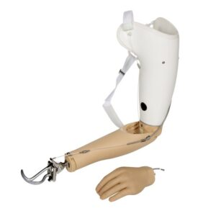

Figure 32: Split hook prosthetic arm

There are very few safety concerns with the prosthetic arm concept, the main being fumes released and solvents used during the 3D printing process. The filament used for 3D printing when heated up produces volatile organic compounds (VOCs) which are not found to be life threatening but can cause side effects such as headaches and nausea. This can be prevented by having a well-ventilated work area, enclosing the 3D printer in a case until the process is finished, or having an air purifier running near the 3D printing workspace [13]. The CDC recommends using PLA filament because it produces less VOCs particles and following the manufacturer’s recommendations for the printing bed and nozzle temperatures [14]. Solvents are used to clean the printing bed and nozzle of the 3D printer. Some of these solvents can be skin, eye, and lung irritants and are to be used with caution, use appropriate PPE if needed.

When dealing with any kind of electrical components there is a risk of electrocution. The design concept for the prosthetic arm would contain low voltage components such as a rechargeable battery pack to power the internal components of the arm and hand. The user while assembling their prosthetic arm is at no risk of life-threatening shocks. There is a goal to waterproof the prosthetic arm enough to withstand rain showers without the electrical components being damaged, but it is not intended at this stage to be fully submerged in water.

Global, Economic, Environmental, and Societal Considerations

Worldwide there are 3 million people whose arm is amputated, with 1.77 million of them being below the elbow and 0.84 million of them having an amputation above the elbow [15]. Over two-thirds of arm amputees live in developing countries where access prosthetics are not widely available or affordable. It is predicted that 8.04 million 3D printers will be purchased globally by 2027 [16]. 3D printers are becoming more available for any person to use whether they buy one for their home or by using 3D printing shops. There are websites that allow people to send in their 3D print files and the company will print it off and mail it back to the customer and this can be globally accessed [17]. The market for 3D printed prosthetics in 2020 was valued at $91.2 million and is expected to reach $620 million by 2027 [18]. 3D printing prosthetics is becoming a very well-known alternative for people who cannot afford medical grade prosthetics but still want the functionality or aesthetics of having one.

3D printing does have an impact on the environment in both positive and negative ways. 3D printing has a very high rate of energy consumption due to the device needing to preheat and work at a slow pace to create a higher quality product [19]. Using a low-temperature filament can help decrease the energy consumption used and is also recommended for less exposure to VOCs. Another environmental concern is the increase in plastic waste that 3D printing creates. Supports are made during the printing process to prevent deformation, hold the part to the printing bed, and to keep overhanging parts of the model attached to the main piece. These supports are removed after the printing process is done and are discarded. Supports do not use a lot of plastic filaments but with the increase in 3D printer sales there will be an increase in wasted plastic from supports. Print failure can also create wasted plastic because once a part has failed to be printed you have to start the part all over again. Research is being done towards creating bioplastics that can be used in a 3D printer that will degrade quicker after being disposed of. One of the main positive environmental impacts that 3D printing has is that it decreases the amount of carbon emissions since the product can be created where it is needed there are no transportation CO2 emissions.

Recommendations

Though the arm was fully operational and exceeded the specified requirements, several components of the arm could benefit from modifications to the current design. It is under our recommendation that the current arm simply needs reworking and not a complete redesign.

1. Electronic Components and Wiring

Currently the wiring and PCB components have extra parts that are unnecessary for the arm to function. Creating a custom PCB using only the required components will help with space issues due to the wiring. Improved cable management and the addition of wire channels will also be essential in making the assembly easier.

The only components we recommend replacing are the wrist actuator and the forearm servo. The wrist actuator functionally works well but is both large and the only 12 Volt component in our parts list. This required the use of two DC to DC buck converters to step down the voltage input from 12 to 6 Volts, which is the operating voltage of all other devices. In addition to these buck converters, an H-Bridge setup was needed to control the wrist actuator. Had the actuators in the hand been selected instead, which are rated for even stronger forces and have a larger actuation distance, there would have been no need for these components. In the end, the total cost would only increase about 20 dollars and reduce required component space in the forearm in half. The forearm servo had more than enough power to rotate the forearm and could potentially be swapped out for one with a lower torque. This will continue to reduce the space required for components and reduce overall costs.

2. Hand

In terms of function this is the strongest feature in the arm’s design. Ideally improving the cables and physical look of the hand will only make it better. Adding some shaping to the palm, different finger shapes, and thumb design will be an ongoing process until the hand looks as realistic as possible.

3. Wrist

With the use of an Actuonix actuator in place of the current wrist actuator, we would recommend redesigning the wrist to have the actuator be moved to the smaller half of the forearm. By having the actuator slightly offset, this would free up space for electronics.

4. Forearm

Similarly, to the wrist, a smaller servo means more space for components and wiring. This should fix a large issue with the wires fed through the lower forearm as they could potentially get caught in the gearing of the forearm. The dimensions of the sliding components could also be reworked and tested due to the amount of friction between the two halves.

5. Elbow

The current design attempted to integrate the elbow into the forearm design. Since this component is only for demonstration, the arm should run off a separate battery and be able to easily detach from the elbow joint. Having this on a separate battery will allow for the use of a more powerful servo without unnecessarily increasing the overall battery size within the forearm itself.

6. General

As the design approaches a finalized electronic design, future teams should investigate waterproofing, heat ventilation, and a PCB that can be sold as a single unit. Cosmetically the arm could be sanded and painted to look more appealing. Creating a guide and giving a recommendation on paints to use for optimal wear could make this a more appealing option to those concerned with the aesthetics of wearing 3D printed parts.

Conclusion

During the project, it has been determined that a 3D printed prosthetic could be a viable option for amputees. The current design presents lots of features that show promise for the future of this project including the hand, finger, and forearm design. While there is still a lot of room for improvement before the arm is ready for daily use, it is more than capable of grabbing and manipulating common objects with ease. Using this report and its included recommendations further development of the arm should prove to be a great learning experience for students and a great resource for amputees around the world.

Acknowledgements

We would like to thank Dr. Ronald Brockhoff (Kansas State University) for his sponsorship and continued support throughout the duration of the design process. Without him, we never would have had the chance to create a product that could potentially improve the lives of so many individuals. We would also like to thank Dr. Terry Beck (Kansas State University) for his continued mentoring, guidance, and advice throughout the duration of the design process.

References

[1] A. Dynamics, “Prosthetic Technology,” *Arm Dynamics*. [Online]. Available: <https://www.armdynamics.com/research-and-technology/prosthetic-technology>.

[2] W. Williams, “Bionic hand price list,” *Bionics For Everyone*, 12-Apr-2022. [Online]. Available: <https://bionicsforeveryone.com/bionic-hand-price-list/>.

[3] “The Hero Arm Overview is a prosthetic arm made by Open Bionics,” *Open Bionics*, 06-Feb-2023. [Online]. Available: <https://openbionics.com/hero-arm-overview/>.

[4] “TrueLimb® prosthetic arm,” *Unlimited Tomorrow*, 11-Aug-2022. [Online]. Available: <https://www.unlimitedtomorrow.com/truelimb/>.

[5] S. Mraz, “Making prosthetic arms for those in need | machine design,” *Machine Design*, 28-Jul-2022. [Online]. Available: <https://www.machinedesign.com/medical-design/article/21247590/maxon-making-prosthetic-arms-for-those-in-need>.

[6] J. Welch, “Mystery markups: Medical supply and drug pricing policies vary across hospitals,” *HFMA*, 07-Nov-2022. [Online]. Available: <https://www.hfma.org/accounting-and-financial-reporting/costing-and-managerial-accounting/57020/>.

[7] P. by R. Errera, “3D printing statistics (2022 additive manufacturing data),” *Toner Buzz*, 10-Jun-2022. [Online]. Available: <https://www.tonerbuzz.com/blog/3d-printing-statistics/>.

[8] *What is the Kano Model?* What is the Kano Model? | Definition and Overview of Kano. (2021, September 2). Retrieved from <https://www.productplan.com/glossary/kano-model/#:~:text=The%20Kano%20Model%20(pronounced%20%E2%80%9CKah,are%20likely%20to%20satisfy%20customers>.

[9] Ezigbo, P., Felix, K., & Chukwuchekwa, N. (2020, April 1). *Development Of 3D Printable Prosthetic Arm For Amputees Using Computer Aided Design And Fused Deposition Modelling*. aeuso.org. Retrieved from <https://aeuso.org/includes/files/jrnl_frmts/IJMEC_Template.docx>

[10] “Standards by ISO/TC 168,” *ISO*, 22-Feb-2023. [Online]. Available: <https://www.iso.org/committee/53630/x/catalogue/>.

[11] “Who standards for prosthetics and orthotics,” *World Health Organization*, 2017. [Online]. Available: <https://www.who.int/publications/i/item/9789241512480>.

[12] “How much does a prosthetic arm cost?,” *CostHelper Health*, 27-Feb-2019. [Online]. Available: <https://health.costhelper.com/prosthetic-arms.html>.

[13] “3D printer fumes: Are they dangerous?,” *Clever Creations*, 01-Jan-2023. [Online]. Available:<https://clevercreations.org/3d-printer-fumes-pla-abs-printing-smell/>.

[14] “3D printing with filaments: Health and safety questions to ask,” *Centers for Disease Control and Prevention*, Mar-2020. [Online]. Available: <https://www.cdc.gov/niosh/docs/2020-115/pdfs/2020-115.pdf?id=10.26616/NIOSHPUB2020115>.

[15] “Limb Loss Stats,” *Group 10*, Sep-2019. [Online]. Available: <https://u.osu.edu/fitness4all/loss-limb-stats/#:~:text=3%20million%20people%20worldwide%20have%20an%20arm%20amputation,and%200.15million%20have%20a%20hand%20or%20should%20amputation>.

[16] “GVR: Global 3D printing market size was $11.58 billion in 2019,” *Printed Electronics Now*, 02-Oct-2020. [Online]. Available: <https://www.printedelectronicsnow.com/contents/view_breaking-news/2020-02-10/gvr-global-3d-printing-market-size-was-1158-billion-in-2019/#:~:text=Globally%2C%201.42%20million%20units%20of%203D%20printers%20were,expected%20to%20reach%208.04%20million%20units%20by%202027>.

[17] M. Griffin, “3D printing near me: How to find a shop or service,” *All3DP*, 07-Jan-2023. [Online]. Available: <https://all3dp.com/2/3d-printing-service-near-me/>.

[18] “Global 3D printed Prosthetics Market Report 2022: Lower costs, Turnaround Time & the capacity for customization driving adoption,” *GlobeNewswire*, 27-Oct-2022. [Online]. Available: <https://www.globenewswire.com/en/news-release/2022/10/27/2542529/28124/en/Global-3D-Printed-Prosthetics-Market-Report-2022-Lower-Costs-Turnaround-Time-the-Capacity-for-Customisation-Driving-Adoption.html>.

[19] “Is 3D printing eco-friendly & sustainable? (answer: Not quite),” *Perch Energy*, 17-Sep-2022. [Online]. Available: <https://www.perchenergy.com/blog/innovation/is-3d-printing-eco-friendly-sustainable>.

Appendices

A. QFD Discussion Ranking

Table 3: QFD Discussion Ranking.

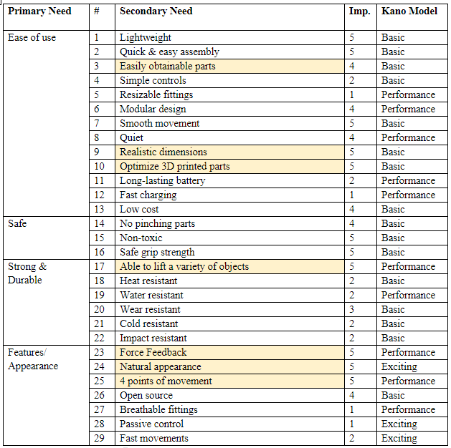

B. Detailed Drawings and Spec Sheets

Figure B.1: Fully labeled drawing & exploded view of prosthetic arm.

Figure B.2: Fully labeled drawing & exploded view of prosthetic hand.

Figure B.3: Exploded view of complete arm model including outsourced parts.

Figure B.4: Exploded view of the prosthetic hand including outsourced parts.

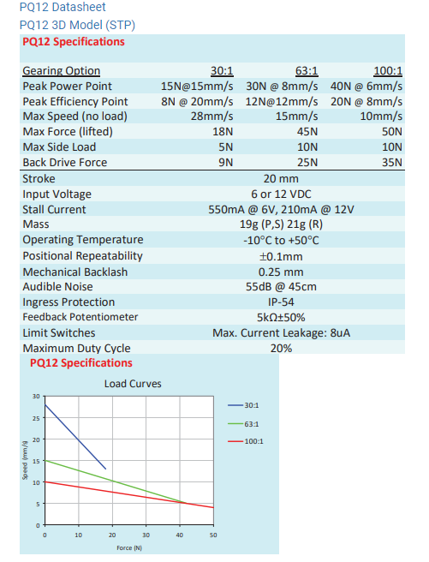

Figure B.5: Spec sheet for the PQ12 100:1 Actuonix Linear Actuator.

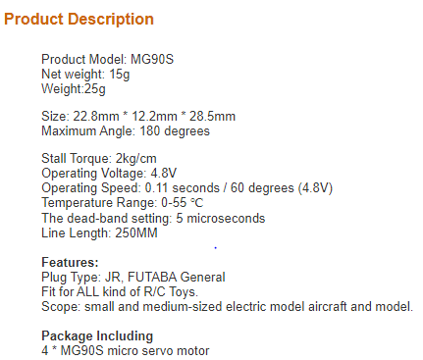

Figure B.6: Spec Sheet for the MG90S Micro Servo.

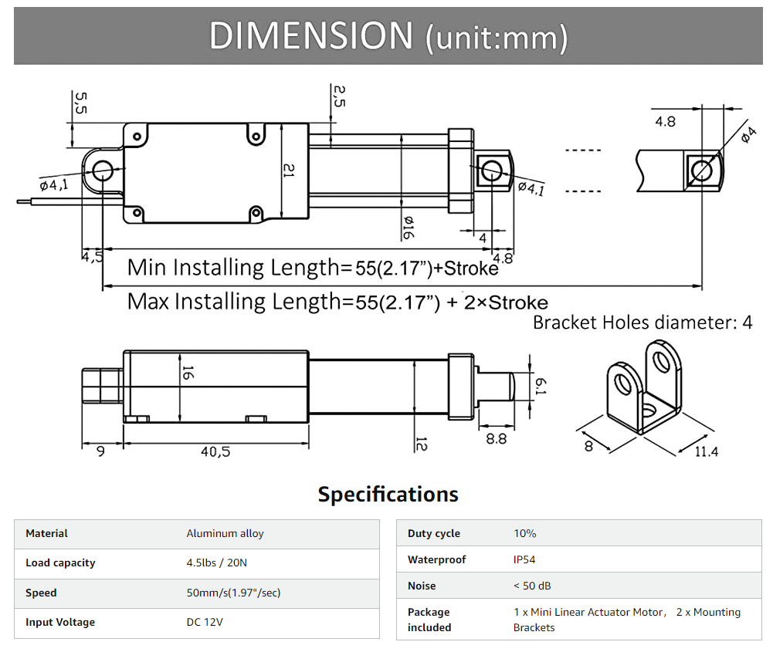

Figure B.7: Spec Sheet for the Mini Electric Linear Actuator.

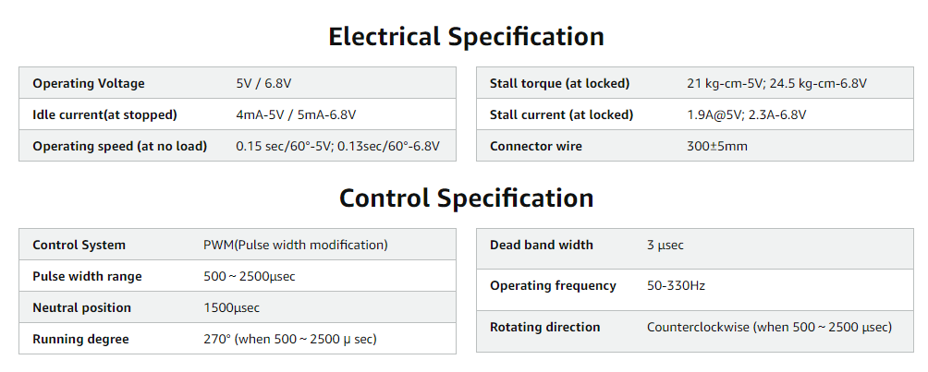

Figure B.8: Spec Sheet for the BETU 25kg Servo.

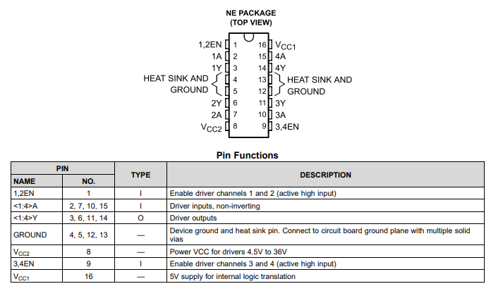

Figure B.9: Spec sheet for SN754410NE H-bridge

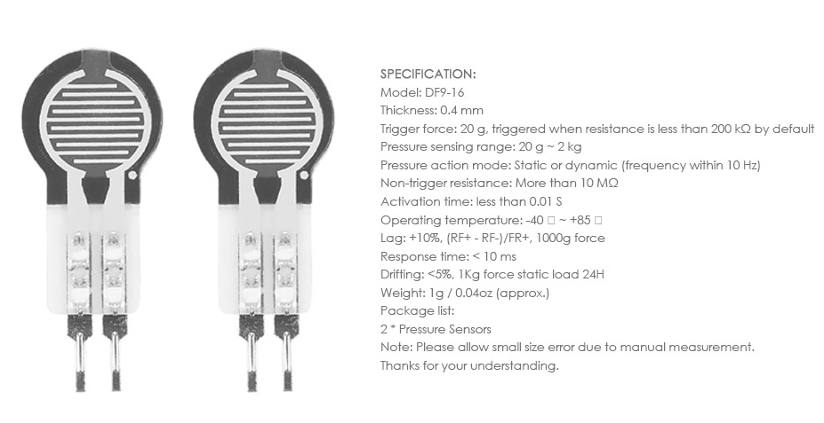

Figure B.10: Spec Sheet for the RP-C resistance type pressure sensor.

C. Original Data

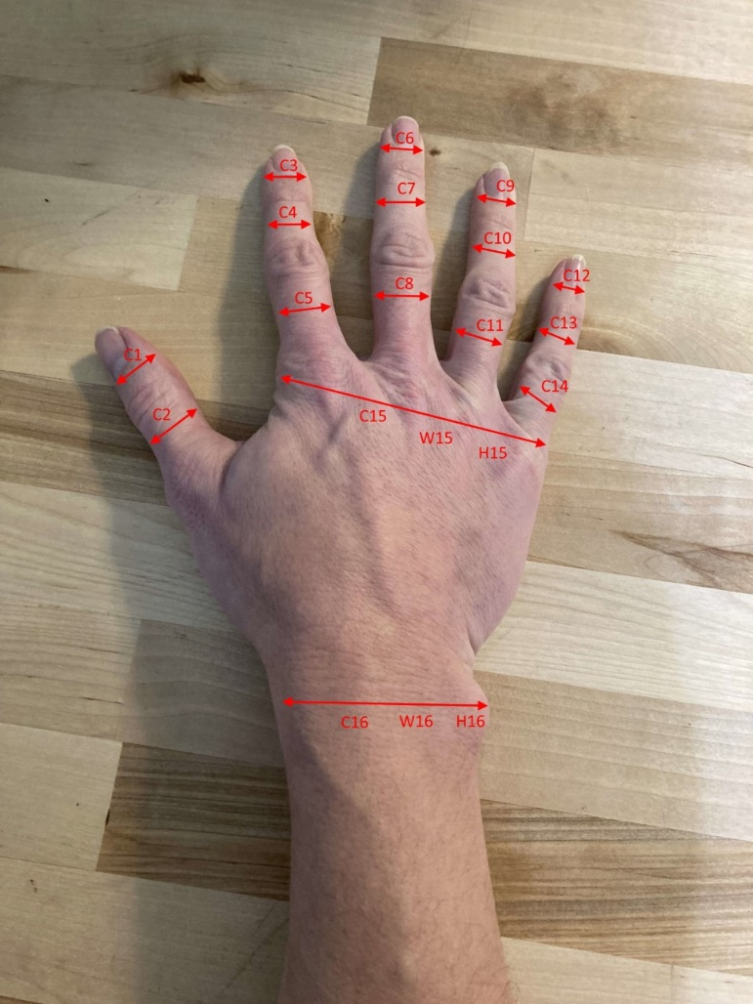

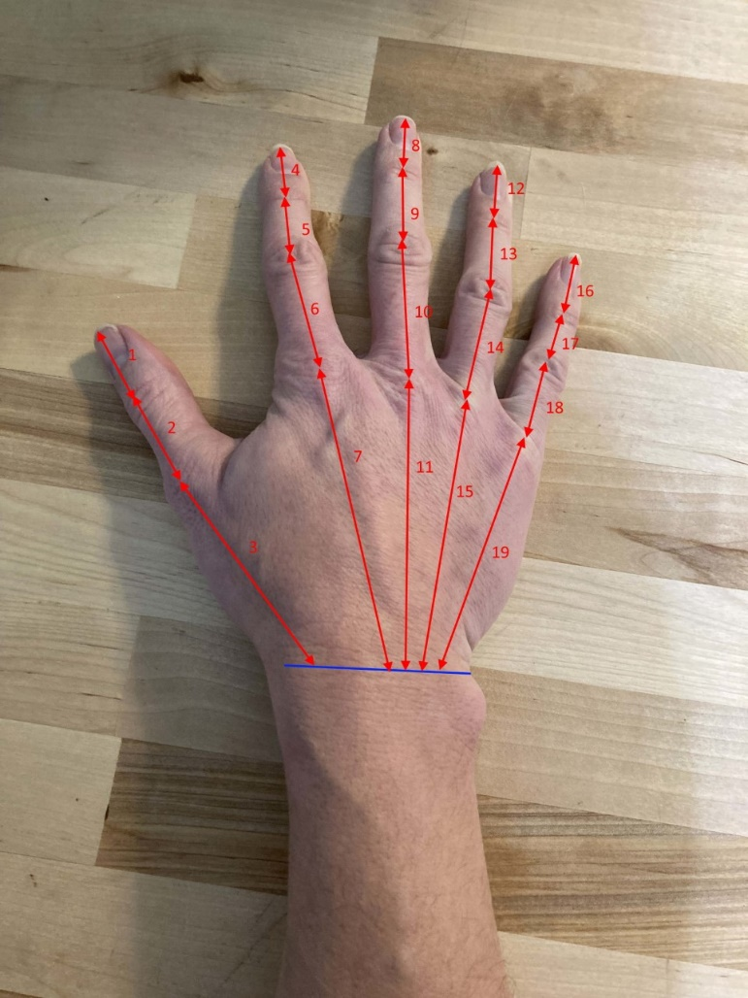

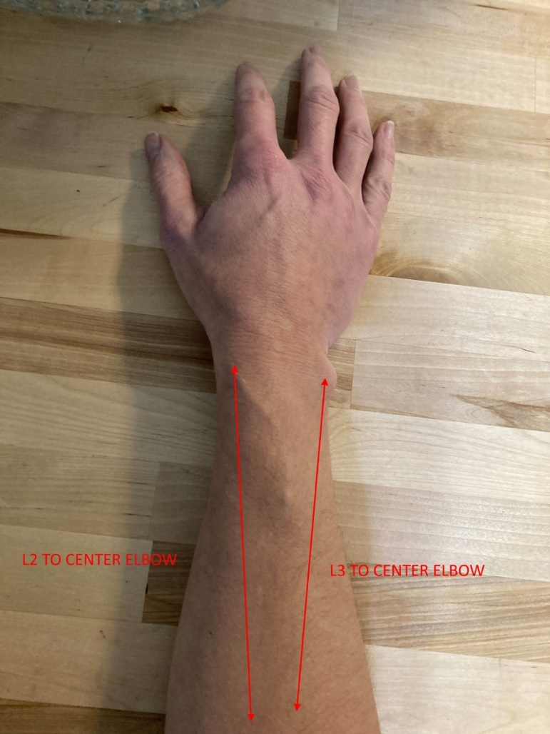

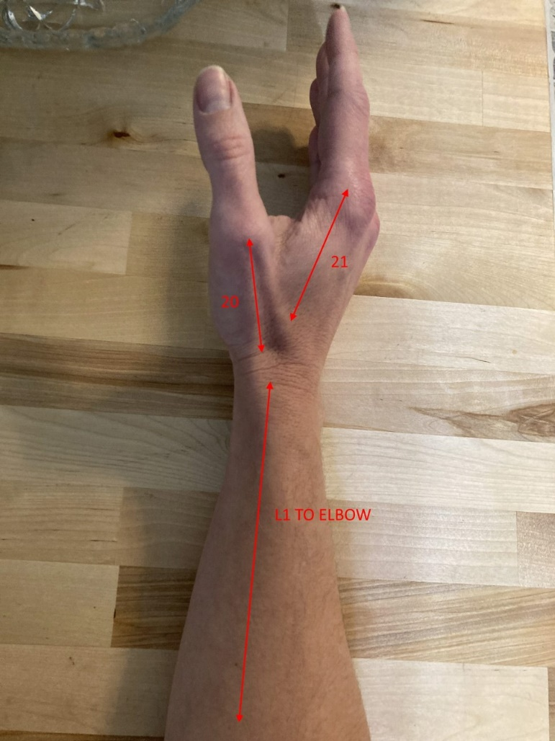

|  |  |
| --- | --- |
| Dimension Number | Brockhoff (in) |
| 1 | 1.375 |
| 2 | 1.625 |
| 3 | 3.250 |
| 4 | 1.000 |
| 5 | 1.250 |
| 6 | 2.125 |
| 7 | 4.250 |
| 8 | 1.125 |
| 9 | 1.500 |
| 10 | 2.375 |
| 11 | 3.750 |
| 12 | 1.125 |
| 13 | 1.500 |
| 14 | 2.375 |
| 15 | 3.250 |
| 16 | 1.000 |
| 17 | 1.000 |
| 18 | 2.000 |
| 19 | 3.250 |
| 20 | 2.500 |
| 21 | 2.500 |
| C1 | 2.125 |
| C2 | 2.375 |
| C3 | 1.875 |
| C4 | 2.250 |
| C5 | 2.750 |
| C6 | 2.000 |
| C7 | 2.250 |
| C8 | 2.500 |
| C9 | 1.625 |
| C10 | 2.000 |
| C11 | 2.500 |
| C12 | 1.625 |
| C13 | 1.750 |
| C14 | 2.250 |
| C15 | 8.500 |
| C16 | 6.500 |
| W15 | 3.750 |
| W16 | 2.500 |
| H15 | 1.000 |
| H16 | 1.375 |
| L1 | 11.000 |
| L2 | 11.000 |
| L3 | 10.500 |